Title:

The Solidarity Profiling Framework: A Pluriversal Methodology for Operationalizing Solidarity in Global Health Decision-Making

Abstract
Solidarity is increasingly invoked in global health to justify equitable partnerships, shared responsibility, community participation, and health system transformation, yet it remains difficult to assess in practice. This paper develops the Solidarity Profiling Framework as a pluriversal methodology for operationalizing solidarity without reducing it to a universal index or ranking. The framework responds to a methodological gap in global health evaluation, where existing tools often privilege technical performance, financial protection, efficiency, or outcome achievement while giving limited attention to the relational, ethical, epistemic, and governance processes through which those outcomes are pursued. Methodologically, the paper advances a qualitative and interpretive profiling approach organized around three dimensions: what values guide a programme, how solidarity is enacted through governance and implementation, and to what end solidaristic action is directed. These dimensions are translated into nine analytical domains covering equity and justice, common good, mutual responsibility, power transformation, inclusive participation, transparency and accountability, sustainability and sovereignty, relational trust, and transformative impact. The paper further introduces the Solidarity Profiling Tool and its digital implementation, SOLIDARIS, as an intelligence-oriented assessment system that supports multi-assessor judgement, evidence documentation, confidence appraisal, integrity checks, consensus deliberation, audit trails, and profile visualization. Rather than producing a single score, the tool generates a contextual solidarity profile that makes visible tensions between rhetoric, evidence, power, participation, and programme outcomes. The framework contributes a practical yet non-reductionist methodology for assessing solidarity and offers a model for operationalizing complex normative concepts in global health evaluation.

Illustrative Proof of Concept
An early spreadsheet proof of concept has already been developed to demonstrate the feasibility of translating the framework into a usable assessment instrument. It includes a context input sheet, a domain assessment sheet, an integrity and risk assessment sheet, a reference guide, calculation logic, and a dashboard. This proof of concept functions as the first operational layer of the wider intelligence system. It demonstrates how contextual programme information, domain ratings, evidence summaries, confidence levels, risk flags, and narrative summaries can be organized into a structured solidarity profile. The spreadsheet is therefore not merely a template; it is an initial prototype showing how the framework’s conceptual architecture can be converted into an evidence-informed workflow.
Figure 1: Snapshot of Excel-Based Solidarity Assessment tool
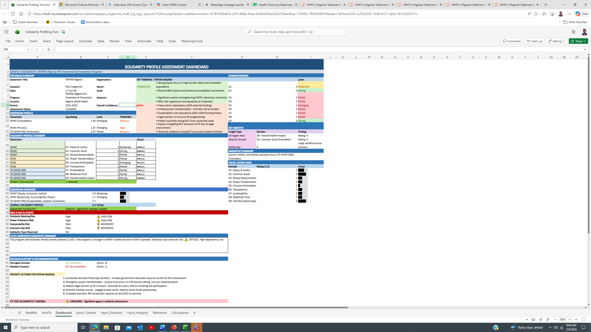
The illustrative sample embedded in the proof of concept (Figure 1) applies the tool to HIV programming in Nigeria.
The example shows how a programme may demonstrate strong technical or outcome-oriented dimensions while revealing weaker performance in local power transformation, inclusive participation, sustainability, or mutual responsibility. This illustrates the central value of the profiling approach: it can distinguish between technical success and solidaristic practice. A programme may achieve important service delivery outcomes while still depending heavily on external financing, limiting community influence over decisions, or failing to institutionalize long-term local ownership. The tool therefore helps make visible the difference between outcome achievement and solidaristic governance.
The proof of concept also informs the ongoing digital implementation of the tool as an intelligence platform. The spreadsheet clarifies the rating logic, domain structure, evidence fields, dashboard outputs, and risk categories, while the digital implementation extends these functions into collaborative assessment, evidence management, auditability, consensus-building, version control, and scalable reporting. In this transition, the tool is no longer simply a spreadsheet-based assessment form. It becomes a structured research and decision-support environment that enables multiple assessors to work independently, compare interpretations, deliberate transparently, preserve disagreement, and generate traceable solidarity intelligence for programme learning and policy dialogue.

